**Year 10 Physics End of Topic Test**

**Name: ________________________________ Score: /39**

**Multiple Choice Answer Sheet (20 marks)**

1. A B C D

2. A B C D

3. A B C D

4. A B C D

5. A B C D

6. A B C D

7. A B C D

8. A B C D

9. A B C D

10. A B C D

11. A B C D

12. A B C D

13. A B C D

14. A B C D

15. A B C D

16. A B C D

17. A B C D

18. A B C D

19. A B C D

20. A B C D

.

**1** Power is the rate at which energy is supplied. What power is needed to supply 6000 J to lift a 15kg child 10 m up a vertical cliff face in 5 seconds?

A 1200 J/s

B 120 J/s

C 300 000 J/s

D 30 000 J/s

Cables

**[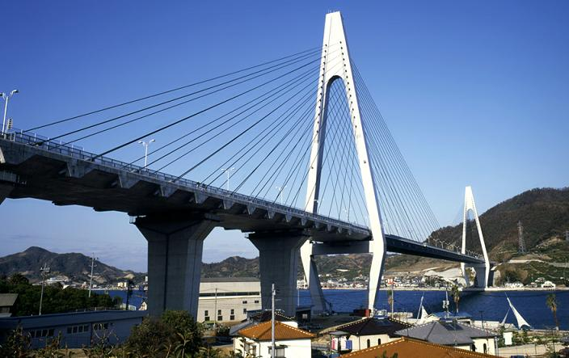](http://www.google.com.au/url?sa=i&rct=j&q=cable%20structure&source=images&cd=&docid=Ia5-jEs6rb-4pM&tbnid=kb2XZHnsRVs7bM:&ved=0CAUQjRw&url=http://www.tradekorea.com/sell-leads/0322/Suspension_Systems.html&ei=q5w7Uq_SIcvbkgWVtICYBw&psig=AFQjCNGzYY-pXnBpvpX-fhpSwjrduWiA5A&ust=1379724824159105)2** Two forces stretch a cable within a structure. Which of the following best describes the cable?

A The cable is in compression.

B The cable is in tension.

C The cable is being stretched by gravity.

D The cable is unbalanced.

**3** When a door or window sticks (is difficult to open) it indicates that the structure:

A has partly failed

B has forces acting on it

C has all of its forces balanced

D has no forces acting on it

**4** An aircraft is flying in a straight line at constant altitude and at a constant speed. What can be said about the forces on the aircraft?

A The forces are unbalanced.

B The forces are balanced.

C The forces are compression forces.

D The aircraft is accelerating.

**5** When standing, your legs are in:

A compression

B tension

C failure

D friction

**6** Sandstone is a building material that is strong under:

A compression only

B tension only

C both compression and tension

D all forces

**7** A cable was placed under tension until just before it broke. Which of the following diagrams best shows the cable just before it broke?

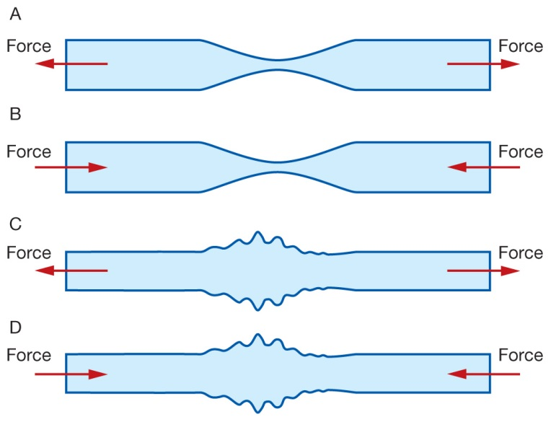

**8** The Sydney Harbour Bridge (diagram below) is an example of a:

A bowstring arch bridge

B cable-stayed bridge

C suspension bridge

D beam bridge



**9** The correct definition for “efficiency” is:

A When a device uses more energy to turn on or off than when it is constantly on

B The stored energy an object has

C The measure of the useful energy output of an energy transfer

D The wasted energy of an object compared to the useful energy in the same object

**10** Which of the following has kinetic energy?

A A bike parked on a hill.

B A child running.

C A stretched balloon.

D A bumblebee hovering in the same spot.

**11** Cooper pulls Jesse on a sled for 10 seconds with a force of 120N over a distance of 3 metres.

The work Cooper has done on the sled is:

A 36 Joules

B 36 Kilojoules

C 360 Kilojoules

D 360 Joules

**A**

[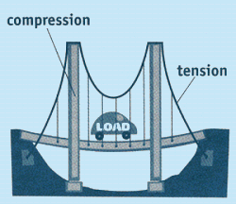](http://www.google.com.au/url?sa=i&rct=j&q=tension+and+compression+structure&source=images&cd=&cad=rja&docid=G3lxRbpcGNLJsM&tbnid=oJ5zGxfMkpJX2M:&ved=0CAUQjRw&url=http://www.carondelet.pvt.k12.ca.us/Family/Math/03210/page4.htm&ei=V9c7UomxLYzFkwXF-IDIAw&psig=AFQjCNEYORpIxQY7OLCRETbBpZif83rsvA&ust=1379739804442263)**12** Which of the following is **true** about this diagram of a bridge?

A A shows an area under compression and B shows an area under tension

**B**

B A shows an area under tension and B shows an area under compression

C Both A and B are under tension

D Both A and B are under compression.

**13** Which of the following is **not** an example of potential energy?

A A bike parked on a hill.

B A skateboard moving down a hill

C A stretched balloon.

D A sandwich

**14** When a phone is plugged into be charged the wire and phone heat up slightly. What can be said about the phone charger

A The charger is inefficient and should be replaced

B Some heat is always ‘lost’ when energy is transformed

C The charger was left on for too long

D All of the above

**15** Mr Norgrove was holding a 300g coffee cup 2m off the ground. How much potential energy does the coffee cup have?

A 5880J

B 5880N

C 5.88J

D 5.88N

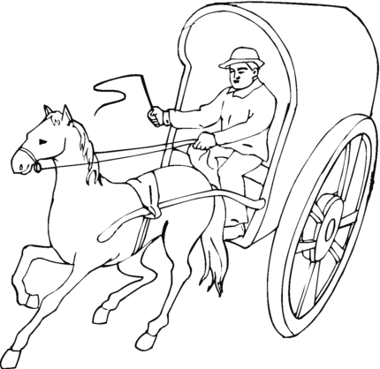**16** A horse pulled a 1000N cart 5km, it took 45minutes. On the way home the driver used the whip and made the horse go faster so it only took 30minutes. Which of the following statements is correct?

A The horse did more work getting home than he did getting there

B The horse did the same amount of work in both directions but used more power on the way home

C The horse has the same power in both directions but did more work on the way home

D None of the above

**17** Ava has a mass of 45 kg. On Planet Aranmoria she weighs 351 N. The acceleration due to gravity on Planet Aranmoria is:

A 7.8ms2

B 7.8ms

C 0.13ms2

D 0.13ms

**18** A 0.5 kg ball is dropped from the top of a 3 metre wall. The ball’s kinetic energy when it hits the ground is:

A 7.35 Joules

B 14.7 Kilojoules

C 14.7 Joules

D 7.35 Kilojoules

**19** Sifa drives around a race course that starts and finishes at the same point. If the race was 1000 metres, what was the displacement of the Sifa when he finished?

A 1000 metres

B 500 metres

C 10 metres

D 0 metres

**20** Consider the diagram below:

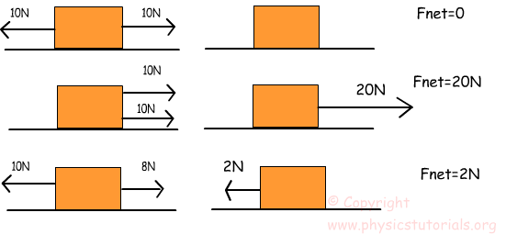 Which of the following statements are true?

A The top block will accelerate while the middle one will continue with its current motion.

B The bottom block will move to the left while the middle block will continue with its current motion.

C The bottom block will move to the left while the top block will continue with its current motion.

D The middle block will move to the right while the top block will stop all movement.

**Short Answer (19 marks)**

**1** Explain why a stretched cable is most likely to break at a scratch. You may use a diagram to help you answer the question in the space below if you need to. (2 marks)

**2** State the law of conservation of energy? (1 mark)

**3** Give an example of where we can see this law in action (2 marks)

**4** Classify each of the components (labelled a, b and c) in the structure below as being in either compression or tension. (3 marks)

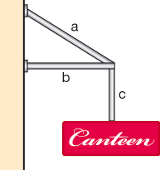a

b

c

**5** When a structure fails, it doesn’t always fall down. List two ways you can tell that some minor failure has occurred in a structure. (2 marks)

1. **6** Father Christmas exerts a force of 800 N on the 40kg loaded trolley as shown. The trolley accelerates at 5 m/s2.

a Friction acts between the trolley and the carpet. **Calculate** the size of the friction force acting on the trolley. (2 marks)

b **Demonstrate** where this force acts by marking the force using an appropriate arrow on the diagram. (1 mark)

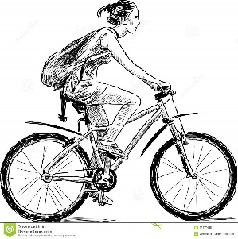**7** Morgan has a mass of 60kg, she is carrying a 2kg back pack and her bike has a mass of 8kg. She is travelling at 15km/hr. DO NOT convert the speed to m/s.

How much kinetic energy does Morgan have? (2 marks)

**8** Ellen also has a mass of 60 and is carrying a 2kg back pack. She has the same bike as Morgan. Ellen rode faster at 30km/hr (DO NOT convert to m/s) and is now resting at the top of a 50m hill. She is still sitting on her bike with her back pack on her back.

How much kinetic energy does Ellen have? (2 marks)

How much potential energy does Ellen have? (2 marks)

**SOLUTIONSMultiple Choice Answer Sheet**

1. A B C D

2. A B C D

3. A B C D

4. A B C D

5. A B C D

6. A B C D

7. A B C D

8. A B C D

9. A B C D

10. A B C D

11. A B C D

12. A B C D

13. A B C D

14. A B C D

15. A B C D

16. A B C D

17. A B C D

18. A B C D

19. A B C D

20. A B C D

**Short Answer**

**2** Explain why a stretched cable is most likely to break at a scratch. You may use a diagram to help you. 2

Lines of stress are closer together at that point

More force in a smaller area

**3** What is the law of conservation of energy? 1

Energy may be transferred or transformed but never destroyed

4. Give an example of where we can see this law in action 2

Any suitable example (1) explained (1)

**5**` Classify each of the components (labelled a, b and c) in the structure below as being in compression or tension. 3

**a** tension

**b** compression

**c** tension

**6** When a structure fails, it doesn’t always fall down. List two ways you can tell that some minor failure has occurred in a structure. 2

Any 2 reasonable answers

1. **7** Father Christmas exerts a force of 800 N on the 40kg loaded trolley as shown.
2. The trolley accelerates at 5 m/s2.

a Friction acts between the trolley and the carpet. **Calculate** the size of the friction force acting on the trolley. 2

F = ma

40x5 = 200

800 – 200 = 600N

b **Demonstrate** where this force acts by marking the force using an appropriate arrow on the diagram. 1

**8** Morgan has a mass of 60kg, she is carrying a 2kg back pack and her bike has a mass of 8kg. She is travelling at 15km/hr. DO NOT convert the speed to m/s.

How much kinetic energy does Morgan have? 2

E (k) = ½ mv^2

= ½ (70)(15)^2

= 7875 J or 7.875 KJ

**9** Ellen also has a mass of 60 and is carrying a 2kg back pack. She has the same bike as Morgan. Ellen rode faster at 30km/hr and is now resting at the top of a 50m hill. She is still sitting on her bike with her back pack on her back. DO NOT convert to m/s.

How much kinetic energy does Ellen have? 2

13 500 J or 13.5 KJ

How much potential energy does Ellen have? 2

PE= mgh

70x9.8x50

34 300 Joules or 34.3 KJ

|  |
| --- |
|  |
|  |
|  |
|  |
|  |
|  |
|  |
|  |
|  |
|  |
|  |
|  |
|  |